Prospectus for B.Ed special Education H.I for 2020-2022
Spastic Society of Manipur is a centre for education and rehabilitation of children with disabilities. The society started in 2004 at Ghari , Airport road and has now shifted its premises to Tapokpi Bazar , Canchipur.
The Society is running early intervention services, special school , vocational training and skill development , awareness programmes , OPD services, home management programmes and sports and recreational activities for the persons with disabilities.
The society has received the National Award for best institution in 2008 .The society has functioned as Extension centre of NIEPMD ,National Institute for Empowerment of Persons with Multiple Disabilities , SNAC National trust , Implementing agency of National programme for prevention and control of Deafness (NPPCD) and State resource centre for Hearing impairment and Locomotor disabilities for NPRPD.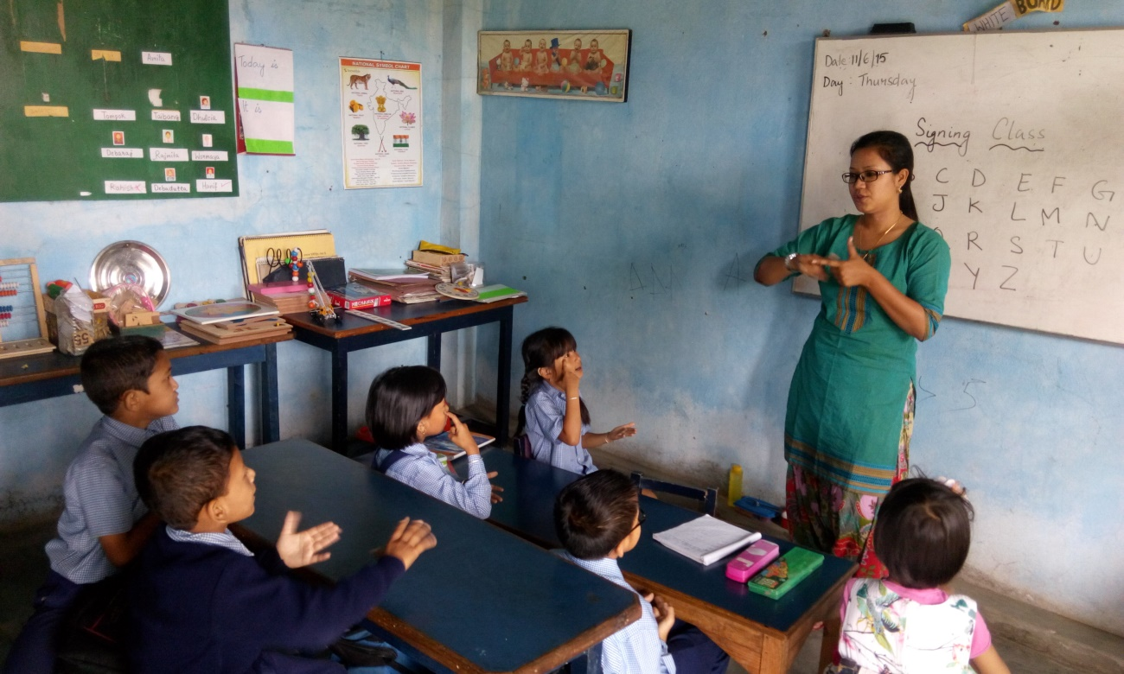
Rehabilitation Council of India has recognised our institute for the B.Ed Special Education Hearing Impairment programme and our institution is affiliated to Manipur University.

OBJECTIVES of the course:
The B.Ed.Spl.Ed. programme aims to develop Special Education teachers/Educators for children with disabilities for various settings (including Inclusive, Special, Open School and Home Based Education).
The B.Ed. (Special Education) programme will prepare human resources to enable them to acquire knowledge and develop competencies and skills to impart education and training effectively to children with disability as well as all other children and this being teachers for all children. After completing the B.Ed. (Special Education) programme the student-teachers will:
a. Acquire knowledge & skills about human development, contemporary Indian education, and pedagogy of various school subjects and assessment for learning.
b. Acquire knowledge & skills about nature and educational needs of children with disabilities as well as of few select specific disabilities.
c. Develop conceptual understanding of educational provisions and skills for working with children with various disabilities in Special and inclusive settings.
d. Enhance knowledge and skills for professional development.
Duration of the course: It is two years programme with two semesters in each year . The course comprises of 64-72 weeks of contact classes with 6-8 weeks of field activities .Each semester will comprise of 16-18 weeks with 2 weeks of field activities.
Minimum Eligibility Conditions: The applicant should have a Bachelor/Master’s Degree from any recognised University with minimum 50% passing marks .
Working Days and Attendance : The programme will be conducted for at least 200 working days each year exclusive of period of examination and admission. The minimum attendance of students have to be 80% for all course works , 90% for all practicum and 100% for school internship (5% attendance may be condoned by head of institution on genuine grounds)
Total number of Seats: The total seats is 30 including all reserved categories.
Medium of Instruction: English
Course fees : The course fees is 30,000/- per semester including University examination fees The cost of the application form and prospectus shall be Rs. 500/- only

Programme Structure for 2 years:
Code | Area | Courses | credits
A | THEORY: Core courses | 5 | 20
B | THEORY: Cross Disability & Inclusion Education  Course (including optional courses) | 6 | 12
C | THEORY :Disability Specialisation Courses (Hearing impairment) | 5 | 18
D | THEORY :Enhancing Professional Capacities (EPC)/  Professional Development Courses | 3 | 06
E | Practical related to disability | 2 | 12
F | Field Engagement /school internship | 3 | 12
 | Total | 24 | 80

Semester Wise Structure :
SEMESTER – I
Course | Course title | Credits | Weightage / Marks
A1 | Human Growth & Development | 4 | 100
A2 | Contemporary India and Education | 4 | 100
B7 | Introduction to Sensory Disabilities (VI, HI, Deaf-blind) | 2 | 50
B8 | Introduction to Neuro Developmental Disabilities (LD, ID/ MR, ASD) | 2 | 50
B9 | Introduction to Locomotor & Multiple Disabilities (Deaf- Blind, CP, MD) | 2 | 50
C12 | Assessment and Identification of Needs | 4 | 100
E1 | Practical: Cross Disability and Inclusion | 2 | 50
 | TOTAL | 20 | 500

SEMESTER – II
Course | Course title | Credits | Weightage / Marks
A3 | Learning, Teaching and Assessment | 4 | 100
A4 | Pedagogy of School Subjects (ANY ONE from Part I to Part V) | 4 | 100
A5 | Pedagogy of School Subjects (ANY ONE from Part I to Part V) | 4 | 100
B6 | Inclusive Education | 2 | 50
C13 | Curriculum Designing, Adaptation and Evaluation | 4 | 100
E2 | Practical: Disability specialization | 2 | 50
 | TOTAL | 20 | 500

SEMESTER – III
Course | Course title | Credits | Weightage/Marks
C14 | Educational Intervention and Teaching Strategies | 4 | 100
C15 | Technology and Disability | 4 | 100
C16 | Psycho Social and Family Issues | 2 | 50
E2 | Practical: Disability Specialization | 4 | 100
F1 | Main disability special school (Related to Area C) | 4 | 100
D17 | Reading and Reflecting on Texts (EPC) | 2 | 50
D18 | Drama and Art in Education (EPC) | 2 | 50
 | TOTAL | 22 | 550

SEMESTER – IV
Course | Course title | Credits | Weightage/Marks
B10 | Skill based Optional Course (Cross disability and inclusion) ANY ONE | 2 | 50
B11 | Skill based Optional Course (specialization disability) ANY ONE | 2 | 50
D19 | Basic Research & Basic Statistic (EPC) | 2 | 50
E1 | Practical: Cross Disability and Inclusion | 4 | 100
F2 | Other disability special school | 4 | 100
F3 | Inclusive school | 4 | 100
 | TOTAL | 18 | 450

PASSING MINIMUM: Minimum 50% marks are essential in all courses for passing in the programme (Grace Marks as per University norms).
- Date of issue of the prospectus cum application form : 21st August 2020
- Last date of submission of complete application form: 5th September 2020

Application Form for Admission to B.Ed Special Education (Hearing Impairment) 2020-2022
- Name of Applicant: ……………………………………………………………..........

- Father’s Name:………………………………………………………………………
- Mother’s Name:………………………………………………………………………....
- Date of Birth : __ __ /__ __/__ __ __ __
- Gender : Male ____ /Female_____ /Others ______
- Marital Status :Married ______ /Unmarried _______
- Nationality :………………………………………………………………………
- Category : SC ____ /ST _____ / OBC ______/ PH _____/GEN ______
- Languages Known:…………………………………………………………………
- Aadhar No: ………………………………………………………………………….
- Address in detail with pincode:……………………………………………………….
…………………………………………………………………………………………………………………………………………………………………………………….
- Phone number: ………………………………………………………………………
- E-mail Address:………………………………………………………………………
- Annual Family Income:…………………………………………………………….
- Whether related to a Person with disability : ………………………………………
……………………………………………………………………………………….(if yes then mention type of disability)

- Detail of Examinations passed :
Sl  No. | Name of the  Exam passed | Name of the  Board/university | Name of the Institute | Year of  Passing | Total  Marks | Marks  obtained | Percentage  obtained
1 | SSC/Xth Std or its equivalent
2 | HSC/XII th Std or its equivalent
3 | Graduation
4 | Post Graduation
5 | Others

DECLARATION
I, ……………………………………………………………………………..do hereby declare that all the information given above is true and correct to the best of my knowledge and belief. If admitted , I promise to abide by the rules , norms and discipline of the institution and RCI .
Date:____/____/_______ ___________________________
Place:________________ Applicant’s Signature
Documents to be submitted
- Attested copy of statement of marks of all examination passed
- Attested copy of proof of date of birth and Aadhar card
- Attested copy of proof of SC/ST/OBC/Disability certificate as applicable
- Transfer certificate /University registration certificate
- Three passport size photographs.

